1.Why are functions advantageous to have in your programs?

**Answer:**

Functions reduce the need for duplicate code. Functions allow the same piece of code to run multiple times. This makes programs shorter, easy to read and update. Information hiding is one of the benefit of function.

2. When does the code in a function run: when it’s specified or when it’s called?

**Answer:**

The code in a function executes when the function is called.

3. What statement creates a function?

**Answer:**

def keyword/statement creates a function.

4. What is the difference between a function and a function call?

**Answer:**

A function is a block of code that does a particular operation and returns a result and a function call is the code used to pass control to a function.

e.g.

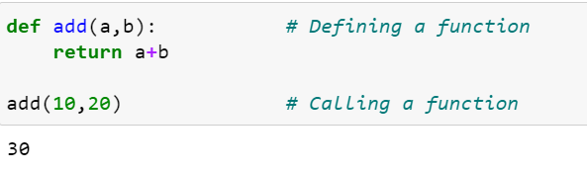

5. How many global scopes are there in a Python program? How many local scopes?

**Answer :**

There is only one global scope and one local scope created per program in python. And it remains in existence till the program is terminated.

6. What happens to variables in a local scope when the function call returns?

**Answer:**

When a function call returns, the local scope is destroyed and all the variables in the scope are forgotten.

7. What is the concept of a return value? Is it possible to have a return value in an expression?

**Answer:**

The value that a function returns to the caller is return value. A python function will always have a return value. So even if you don’t use a return value in return statement it’ll implicitly return a default value. Like any value, a return value can be used as a part of an expression.

8. If a function does not have a return statement, what is the return value of a call to that function?

**Answer :**

If a function does not have return statement, its return value is None.

9. How do you make a function variable refer to the global variable?

**Answer:**

Using keyword “global” we’ll make a function variable as a global variable.

10. What is the data type of None?

**Answer:**

NoneType is the data type of None

11. What does the sentence import areallyourpetsnamederic do?

**Answer**:

This statement will import the module named areallyourpetsnamederic

12. If you had a bacon() feature in a spam module, what would you call it after importing spam?

**Answer:**

Spam.bacon()

13. What can you do to save a programme from crashing if it encounters an error?

**Answer:**

We can place the statements that might causes error in Try block so this way it’ll throw an error instead of crashing.

14. What is the purpose of the try clause? What is the purpose of the except clause?

**Answer:**

The try block lets you test a block of code for errors. The except block lets you handle the error.